SUPPLY CHAIN RESEARCH
Multi-Carrier Parcel Shipping
The 2026 Buyer’s Guide & Vendor Landscape
A practitioner’s guide to evaluating, costing, and selecting multicarrier parcel management software: what these systems do, how rate shopping works, how the market and vendors stack up in 2026, what they cost, and why parcel is a specialized capability that general TMS and WMS platforms leave to others.
Prepared by Supply Chain Research · 2026 · Independent, vendor-neutral research

Contents
1 Executive summary
2 What multicarrier parcel software is
3 The parcel software market in 2026
4 The vendor landscape
5 How to evaluate a parcel platform
6 Cost and pricing
7 Implementation: where programs succeed or fail
8 Trends shaping 2026
9 Segment-specific guidance
10 ROI and the business case
11 Frequently asked questions
12 Recommendations
13 Methodology and caveats
14 Sources

1. Executive summary
Multicarrier parcel management software picks the best carrier for every parcel and gets it out the door. Given an order, it compares contracted carriers on cost, speed, zone, and performance, selects one according to business rules, generates the compliant label and manifest, produces any customs documents, and feeds tracking and status back to the customer. Increasingly it also powers the delivery options shown at checkout and the post-purchase tracking and returns experience. The reason this is a distinct category, rather than a feature of a warehouse or transportation system, is telling: as Gartner observes, most enterprise resource planning, transportation, order, and warehouse management vendors do not specialize in parcel, so they partner with a dedicated parcel solution instead. In 2026 the category is being reshaped by AI, by a shift from cheapest-carrier to risk-aware selection, by consolidation, and by relentless growth in parcel volume.
This guide is written for e-commerce, retail, and supply chain leaders evaluating a parcel shipping investment, and for the teams who must connect it to the warehouse, order, and e-commerce systems. It is deliberately vendor-neutral: we accept no payment from the vendors covered, and we name no single best platform, because the right choice depends on your volume, your carriers, your regions, and whether you want an enterprise engine, a developer API, a packaged e-commerce app, or a post-purchase layer. The pages that follow define the category, size the market honestly while separating the software from the vast parcel economy it serves, profile the enterprise, API, and e-commerce tiers, lay out an evaluation framework, and explain why carrier integration and rate accuracy, not the label engine, decide the return.
~$0.6 to 2.5B  the size of parcel software by scope, a sliver of the parcel-delivery economy | Market Guide  Gartner names Representative Vendors, not a ranked Magic Quadrant | +40% by 2028  Gartner's forecast for the growth in global parcel volumes

What the evidence says
• It is a small category serving a huge economy. Parcel software is roughly $0.6B to $2.5B by scope, a sliver of the multi-hundred-billion-dollar parcel-delivery market, so keep the software separate from the shipping.
• Parcel is a specialized capability gap. Most ERP, transportation, order, and warehouse systems do not specialize in parcel, so they partner with a dedicated multicarrier parcel solution, which is why the category exists.
• Gartner uses a Market Guide, not a quadrant. Gartner covers this market with a Market Guide naming Representative Vendors rather than a ranked Magic Quadrant, reflecting a fragmented, specialized field.
• Rate shopping is the core function. Selecting the best carrier for each parcel from contracted carriers is the heart of the software, and selection is shifting from cheapest to risk-aware, weighing reliability and promised delivery.
• Carrier integration decides success. The recurring challenge is connecting and maintaining carrier integrations and loading accurate negotiated rates, not the label generation, and agentic carrier integration is an emerging answer.

2. What multicarrier parcel software is
A multicarrier parcel management solution selects carriers, produces labels, and manages the parcel from order to doorstep. The core capabilities are:
- Rate shopping and carrier selection. Choosing the best contracted carrier for each parcel by cost, speed, zone, weight and dimensions, and carrier performance, under business rules.
- Label and manifest generation. Producing carrier-compliant labels and shipper manifests, and customs documents for international shipments.
- Tracking and status messaging. Providing shipment status to customers and service teams, and increasingly a branded post-purchase experience.
- Carrier rate management. Maintaining the contracted rates and accessorials that rate shopping depends on, across all carriers.
- Integration with core systems. Connecting to warehouse, transportation, order, and e-commerce systems so shipping fits the wider workflow.

Why parcel is its own category
The most important thing to understand about this market is why it exists separately at all. Parcel shipping is unusually complex: a large and shifting library of carriers, each with its own rates, services, label formats, and compliance rules, plus regional carriers, customs, and a customer who expects real-time tracking. As Gartner notes, most providers of enterprise resource planning, transportation management, order management, and warehouse management systems do not build deep parcel capability; instead they partner with a non-competing multicarrier parcel solution to serve their customers. That leaves a genuine capability gap that a specialized parcel platform fills. It is why a company can run a capable warehouse or transportation system and still need a dedicated parcel solution alongside it.
System | What it does | Relationship to parcel software
Parcel software (MCPMS) | Selects carriers, ships parcels | The subject here
WMS | Runs the warehouse | Partners with a parcel solution
TMS | Plans freight, mostly non-parcel | Often partners for parcel
OMS / e-commerce | Takes and manages orders | Feeds orders to parcel software

Parcel software is distinct from the warehouse, transportation, and order systems around it, which is precisely why it is bought as a specialized solution rather than assumed to be part of them. Deciding which delivery model fits, an enterprise shipping engine, a developer API, a packaged e-commerce app, or a post-purchase experience layer, is the first scoping decision.

3. The parcel software market in 2026
Multicarrier parcel software is a small category whose sizing varies widely by scope, and which is easy to confuse with the vast parcel-delivery economy it serves. Narrow estimates for the carrier-selection software sit near $0.6B to $0.7B; broader estimates that fold in execution, tracking, and post-purchase reach around $2.5B. Either way, it is a sliver of a parcel-delivery market measured in hundreds of billions. Treat the figures below as directional, and check what each one is counting.
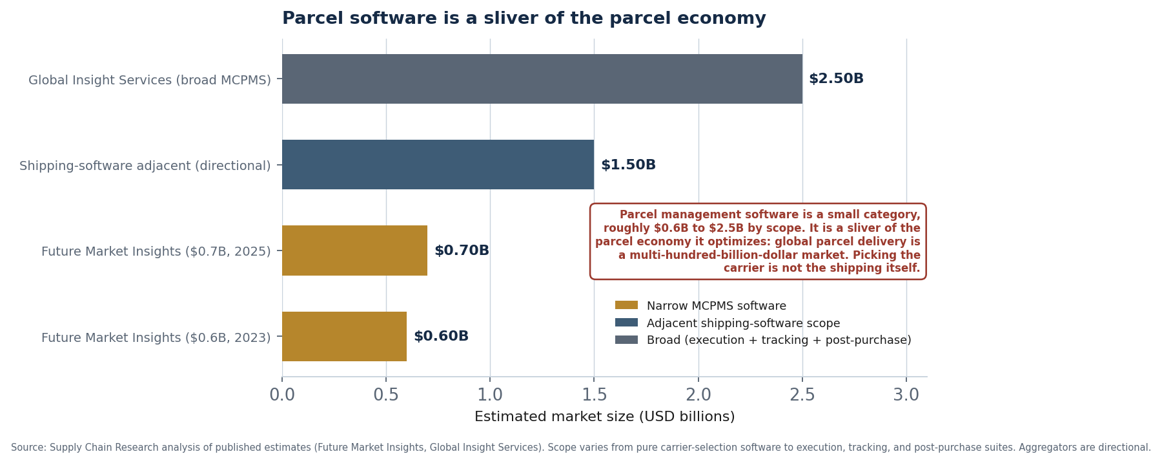
Figure 1. Published estimates by scope. Parcel software ranges from roughly $0.6B to $2.5B, a small fraction of the parcel-delivery economy it optimizes.
Source and scope | Size | Forecast | CAGR
Global Insight Services (broad) | $2.50B (2023) | $5.9B / 2033 | 9.1%
Future Market Insights (2025) | ~$0.70B (2025) | ~$1.8B / 2035 | ~10%
Future Market Insights (2023 base) | $0.60B (2023) | $1.52B / 2033 | 9.7%
Global parcel delivery market (context) | hundreds of $B | growing fast | --

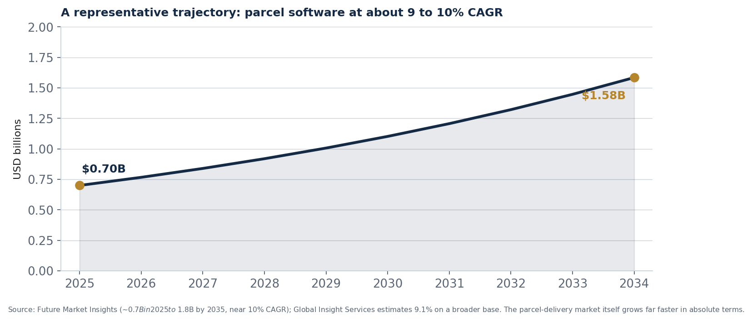
Figure 2. A representative trajectory for parcel software at about 9 to 10 percent CAGR. Estimates cluster in this range across scopes.

Why the estimates diverge
The spread is scope. The narrowest figures count the carrier-selection and label software alone and sit under $1B; the broader figures add shipment execution, tracking, and post-purchase experience and reach a few billion. The deeper point is that all of these are dwarfed by the parcel-delivery market itself, the carriers, the trucks, the last mile, which runs into the hundreds of billions; the software that decides which carrier to use is a thin, high-value layer on top. North America leads, Europe is strong, Asia-Pacific is the fastest-growing, and cloud deployment is now the largest share. For planning, the narrow figures under $1B are the most defensible baseline for the pure software category, provided the parcel-delivery economy is never mistaken for the software market.

Growth in parcel volume drives the category
The force behind this market is parcel volume. Gartner forecasts that global parcel volumes will grow by roughly forty percent by 2028, extending years of e-commerce-driven expansion, and every additional parcel raises the value of software that can select the cheapest or most reliable carrier and process shipments at speed. Rising delivery costs, driven by fuel and labor inflation, and customer expectations for fast, transparent delivery, reinforce the need. The category grows not because the software market is large, but because the volume of parcels it manages keeps climbing.

4. The vendor landscape
The parcel software market spans enterprise shipping engines, API-first platforms, packaged e-commerce shipping apps, and post-purchase and tracking specialists. We group vendors into four tiers by delivery model, not by size. The market is fragmented and consolidating, with roll-ups such as Auctane and E2open absorbing multiple brands.

What the analysts say
The analyst picture here has a distinctive shape. The essentials:
- Gartner uses a Market Guide, not a Magic Quadrant. Gartner covers this market through its Market Guide for Multicarrier Parcel Management Solutions, naming Representative Vendors rather than ranking them, most recently in mid-2026 following prior editions.
- The core finding is the partnership gap. Gartner emphasizes that most enterprise, transportation, order, and warehouse systems do not specialize in parcel and partner with a dedicated solution, which defines the category's reason to exist.
- Consolidation shapes the field. Roll-ups such as Auctane, which owns ShipStation, Metapack, and others, and E2open, which acquired Logistyx, have concentrated multiple brands under single owners.
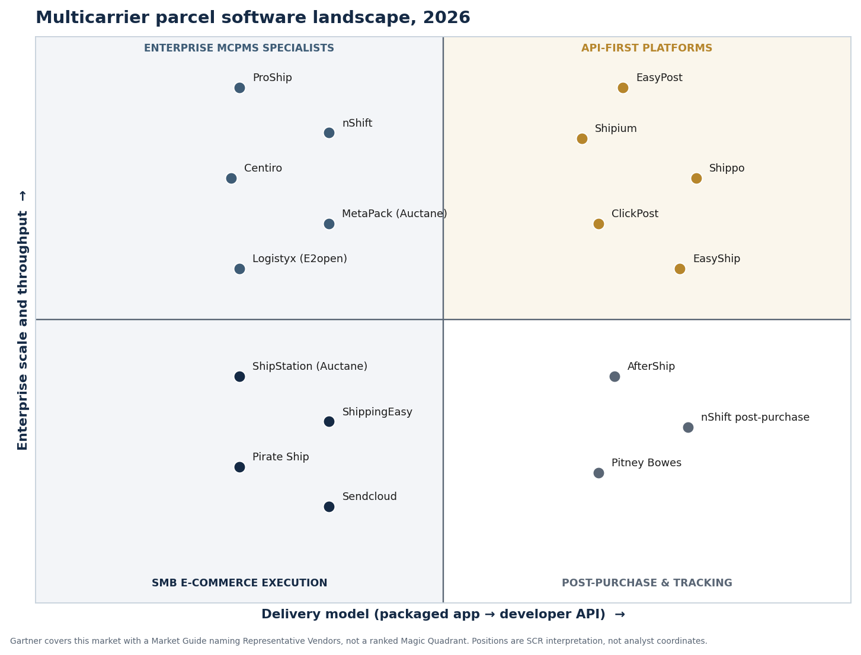
Figure 4. Supply Chain Research's directional map. Gartner names Representative Vendors, not quadrant positions; these are our interpretation, not analyst coordinates.

Enterprise MCPMS specialists
These vendors handle high-volume, complex parcel operations. ProShip is a high-performance enterprise engine built for very high throughput, certified carrier connections, and complex rules, integrating with warehouse and order systems from Manhattan, Blue Yonder, and Korber. nShift is the European leader, connecting to more than a thousand carriers and spanning checkout, shipping, tracking, and returns, formed from the merger of several delivery-software companies and now investing heavily in AI. Centiro, Metapack, now part of Auctane, Pitney Bowes, and Logistyx, now part of E2open, round out the group. Strengths: scale, carrier breadth, and deep integration. Limitations: they are heavier, more expensive deployments suited to large shippers.

API-first platforms
These vendors deliver shipping as developer-friendly infrastructure. EasyPost offers a widely used shipping API with strong documentation, Shipium brings a modern, machine-learning-optimized platform with network simulation built by former large-scale e-commerce operators, and Shippo, ClickPost, and EasyShip provide flexible API-led shipping. Strengths: flexibility, modern architecture, and fit for teams that want to build shipping into their own systems. Limitations: they require technical resources, and the packaged workflow is lighter than an enterprise engine or e-commerce app.

E-commerce apps and post-purchase
Two further groups complete the picture. Packaged e-commerce shipping apps, ShipStation and ShippingEasy, both part of Auctane, Pirate Ship, and Sendcloud in Europe, give small and mid-market sellers label generation, rate comparison, and order consolidation across marketplaces with little setup. And post-purchase and tracking specialists, AfterShip and nShift's post-purchase layer, focus on branded tracking, notifications, and returns after the label is created. Strengths: ease of use and, respectively, the customer experience. Limitations: the e-commerce apps are not enterprise engines, and the post-purchase tools address a slice of the workflow rather than the whole.

Vendor summary
Vendor | Tier | Best fit | Notes
ProShip | Enterprise MCPMS | High-throughput, complex rules | Certified engines; WMS/OMS integration
nShift | Enterprise MCPMS | European, end-to-end delivery | 1,000+ carriers; AI Companion
Centiro / Metapack / Logistyx | Enterprise MCPMS | Large retail and 3PL | Metapack owned by Auctane; Logistyx by E2open
EasyPost | API-first | Developer-led shipping | Strong API and documentation
Shipium | API-first | Modern high-volume e-commerce | ML optimization and simulation
Shippo / ClickPost / EasyShip | API-first | Flexible API shipping | Varied carrier coverage
ShipStation / ShippingEasy | E-commerce app | SMB and mid-market sellers | Auctane-owned; easy setup
AfterShip | Post-purchase / tracking | Branded tracking and returns | Customer-experience layer

Positions and notes are Supply Chain Research's interpretation from public information and the Gartner Market Guide, current to mid-2026. Gartner names Representative Vendors and does not rank them. Ownership changes quickly, including Auctane's ownership of ShipStation and Metapack and E2open's of Logistyx; verify current details directly with each vendor.

5. How to evaluate a parcel platform
The differentiators in parcel software are carrier coverage, rate-shopping sophistication, and the delivery model, more than the label output. We use five dimensions.

The five evaluation dimensions
- Carrier network and your carriers. Does the platform connect to the specific national, regional, and international carriers you use, and can it add new ones without heavy effort?
- Rate-shopping sophistication. How intelligently does it select carriers, is it cost-only, or risk-aware, weighing reliability, exception likelihood, and promised delivery, using your negotiated rates?
- Integration with your systems. How cleanly does it connect to your warehouse, order, and e-commerce platforms, since parcel software must fit the wider fulfillment workflow?
- Delivery model and scale. Do you need an enterprise engine, a developer API, a packaged e-commerce app, or a post-purchase layer, and does the platform match your volume and technical resources?
- Neutral or middleman, and experience. Does it use your own negotiated rates, neutral, or resell carrier services at marked-up rates, middleman, and how strong are its tracking and returns capabilities?

Making the decision
Match the platform to your volume, carriers, and model. High-volume, complex enterprises reward the enterprise engines such as ProShip and nShift. Teams building shipping into their own systems reward the API-first platforms such as EasyPost and Shipium. Small and mid-market sellers reward the packaged e-commerce apps such as ShipStation. Brands focused on the customer experience reward the post-purchase specialists such as AfterShip. Then confirm carrier coverage and rate accuracy on your own shipments, and check whether pricing is neutral or a middleman markup at your volume.

A selection process that works
- List your carriers and regions, and confirm the platform covers them and can add more easily.
- Test rate shopping with your own negotiated rates and delivery rules on real orders.
- Probe integration with your warehouse, order, and e-commerce systems early.
- Choose the delivery model, enterprise, API, e-commerce app, or post-purchase, that fits your scale.
- Check whether pricing is neutral or middleman, and model total cost at your volume.

6. Cost and pricing
Parcel software pricing varies sharply by model, from per-label fees to enterprise licenses, and the neutral-versus-middleman distinction can change the economics. The models you will encounter:
Pricing model | Typical basis | Notes
Per label / shipment | Volume of labels | Common for apps and APIs
Subscription tiers | Features and volume | SMB and mid-market apps
Enterprise license | Platform and volume | Engines can start ~$40K/yr
Middleman markup | Marked-up carrier rates | Can beat rates only at low volume
Setup and per-carrier fees | Integration, sometimes per carrier | Some charge per carrier connected

What drives the number
Volume and model are the main cost drivers. Packaged apps and APIs typically charge per label or by subscription tier; enterprise engines carry a license that can start around forty thousand dollars a year and rise with implementation and engineering. A crucial and often-missed distinction is neutral versus middleman: neutral platforms use your own negotiated carrier rates, while middleman services resell carrier capacity at their own rates, which can undercut a small shipper without negotiated discounts but become expensive at scale. Setup and carrier-integration fees add up, and some vendors even charge a fee per carrier connected. The most common costing mistake is comparing only the headline subscription while ignoring per-label fees, setup, and the neutral-versus-middleman question. Model the full cost at your volume, including labels, setup, and the rate model.
Parcel pricing depends heavily on volume, the delivery model, and whether the platform is neutral or a middleman, so published figures should be treated as starting points. Build a total-cost comparison at your real volume, and test the rate model with your negotiated rates, into the buying process.

7. Implementation: where programs succeed or fail
Parcel software programs fail in predictable ways, and the failures cluster around carrier integration and rate data, not the label engine. The recurring causes:
- Carrier integration is underestimated. Each carrier connection, with its own rates, services, and label rules, takes work to build and certify, and if the effort is underestimated the platform cannot ship through the carriers you need.
- Negotiated rates are loaded incorrectly. If the contracted rates and accessorials are not entered accurately, rate shopping selects the wrong carrier and the promised savings evaporate, because the whole function depends on correct rates.
- Integration with core systems is weak. If the platform does not connect cleanly to the warehouse, order, and e-commerce systems, shipping becomes a disconnected step that slows fulfillment rather than speeding it.
- The wrong model or rate structure is chosen. If a high-volume shipper picks a middleman platform, or a small seller takes on an enterprise engine, the economics and the fit are wrong from the start.

Carriers  connecting and certifying carrier integrations is the core work | Rate data  accurate negotiated rates are what make rate shopping pay | Fit  the delivery model and rate structure must match your scale

Three principles that separate success from failure
• Treat carrier integration as the critical path. Plan and resource the carrier connections first, because the platform can only ship through the carriers it is integrated and certified with.
• Get the negotiated rates right. Load and verify your contracted rates carefully, because rate shopping only saves money when it compares against accurate rates.
• Match the model and rate structure to your scale. Choose enterprise, API, or e-commerce app, and neutral or middleman, according to your volume, because the wrong fit undermines both cost and workflow.

A phased rollout
Sequence the program to prove value early. Begin with your highest-volume carriers and lanes, integrating and certifying those carriers, loading their negotiated rates accurately, and connecting the platform to your warehouse and order systems. Prove the rate-shopping savings and the shipping throughput, then add more carriers and regions, layer in checkout delivery options and post-purchase tracking, and extend returns. Treating these as sequential stages, rather than connecting every carrier at once, is what separates a smooth rollout from a stalled one.

8. Trends shaping 2026

AI and agentic carrier management
The dominant trend is AI applied to parcel: machine-learning rate-shopping and network optimization, AI assistants that configure delivery settings in plain language, and, newly, agentic carrier integration that reduces the manual work of adding and maintaining carrier connections. Because carrier integration is the hardest part of running a parcel platform, agentic approaches that automate it are among the most consequential developments in the category, and leading vendors are racing to deploy them.

Risk-aware rate shopping
Carrier selection is shifting from cheapest to smartest. Rather than simply picking the lowest rate, platforms increasingly weigh carrier reliability, the likelihood of exceptions, and the promised delivery date, choosing the carrier most likely to deliver on time rather than the one that costs least. As delivery-speed expectations tighten and the cost of a failed delivery rises, this risk-aware approach is becoming the mark of a sophisticated platform.

Post-purchase experience and returns
The parcel platform is extending beyond the label into the customer experience: branded tracking, proactive status updates, and streamlined returns. With most consumers expecting proactive delivery updates and returns a major cost and loyalty factor, these post-purchase capabilities are increasingly a differentiator, and the boundary between shipping software and customer-experience software is blurring.

Sustainability and regional carriers
Two related trends are reshaping carrier choice. Carbon and route-level emissions estimates are increasingly used to guide selection, especially for brands with published sustainability commitments. And shippers are adding regional carriers for specific zones to improve speed, reduce cost, and lessen dependence on the national carriers, making multicarrier flexibility more valuable than ever.

Consolidation and agentic frontiers
The market continues to consolidate, with roll-ups such as Auctane and E2open concentrating multiple brands under single owners, which buyers should weigh for roadmap clarity. As across supply chain software, agentic AI is an emerging frontier, here focused on carrier integration and delivery configuration, though it is early and demonstrated capability should be weighed over roadmap promises.

9. Segment-specific guidance
The right platform depends on your scale, technical resources, and priorities. The table summarizes where each segment usually starts; the prose adds the nuance.
Buyer profile | What matters most | Where to start
High-volume enterprise | Throughput, carrier breadth | ProShip, nShift
Developer-led team | API, flexibility | EasyPost, Shipium, Shippo
SMB / mid-market seller | Ease of use, multichannel | ShipStation, ShippingEasy, Sendcloud
Experience-led brand | Tracking, returns | AfterShip, nShift post-purchase
European operation | Regional carriers, checkout | nShift, Sendcloud

High-volume enterprises reward the throughput and carrier breadth of the enterprise engines. Developer-led teams reward the flexibility of the API-first platforms. Small and mid-market sellers reward the ease and multichannel reach of the packaged e-commerce apps. Experience-led brands reward the tracking and returns of the post-purchase specialists, and European operations reward platforms strong in regional carriers and checkout. The unifying rule is to match the delivery model to your scale and technical resources, then confirm carrier coverage.

10. ROI and the business case
The business case for parcel software rests on shipping cost and customer experience. The levers are cheaper and smarter carrier selection using your negotiated rates, faster and more accurate shipping, and a better delivery and returns experience. The discipline is anchoring the case to your own parcel volume and shipping cost, and treating vendor figures as a ceiling.
Rate shopping  selecting the best carrier per parcel cuts shipping cost | Efficiency  automated labels and manifests speed processing and cut errors | Experience  tracking and returns reduce inquiries and lift loyalty

Where the value comes from
Most of the direct return comes from rate shopping. By comparing contracted carriers on every shipment and selecting the cheapest or best-value option using your own negotiated rates, a parcel platform reduces shipping cost, the largest variable cost in parcel fulfillment, and risk-aware selection reduces the costly failures of late or exception-laden deliveries. Beyond that, automated label and manifest generation speeds processing and cuts the errors that cause misships and re-labeling, and a strong post-purchase experience reduces where-is-my-order inquiries, lowers cart abandonment through better checkout options, and makes returns more efficient. These benefits are real but vary widely by shipper, and vendor figures should be treated as a ceiling. The business case is strongest for high-volume shippers with negotiated carrier rates and complex, multichannel fulfillment, but the value should be modeled on your own parcel volume, shipping cost, and carrier mix, with vendor figures used only to size the opportunity.

11. Frequently asked questions
What is multicarrier parcel management software?
Software that selects the best contracted carrier for each parcel, generates compliant labels and manifests and customs documents, provides tracking and status, and manages carrier rates. Increasingly it also powers checkout delivery options and the post-purchase tracking and returns experience. Its core function is rate shopping: choosing the right carrier for every shipment.
Why isn't parcel just part of my TMS or WMS?
Because most transportation, warehouse, order, and enterprise systems do not build deep parcel capability. As Gartner notes, they typically partner with a non-competing multicarrier parcel solution instead. Parcel is unusually complex, a large, shifting library of carriers with distinct rates, formats, and rules, so it is filled by specialized software alongside those systems.
Is there a Gartner Magic Quadrant for parcel software?
No. Gartner covers this market with a Market Guide for Multicarrier Parcel Management Solutions, which names Representative Vendors and describes market trends, rather than ranking vendors in a Magic Quadrant. The most recent guide was published in mid-2026, following earlier editions.
Who are the leading vendors?
It depends on the delivery model. Enterprise engines include ProShip and nShift; API-first platforms include EasyPost and Shipium; packaged e-commerce apps include ShipStation and ShippingEasy, both owned by Auctane; and post-purchase specialists include AfterShip. Consolidation is notable, with Auctane and E2open, which acquired Logistyx, owning multiple brands.
How big is the market?
It depends on scope. Narrow estimates for the carrier-selection software sit near $0.6B to $0.7B; broader estimates that add execution, tracking, and post-purchase reach around $2.5B, growing at roughly nine to ten percent. Either way it is a sliver of the parcel-delivery economy, which runs into the hundreds of billions. The narrow figures are the most defensible baseline.
What is rate shopping?
The core function of parcel software: given a shipment, compare all contracted carriers on cost, speed, zone, and performance, and select the best one under your business rules, using your negotiated rates. Selection is shifting from simply the cheapest to risk-aware, weighing carrier reliability, the likelihood of exceptions, and the promised delivery date.
What is the difference between a neutral and a middleman platform?
A neutral platform uses your own negotiated carrier rates and charges for the software; a middleman resells carrier capacity at its own marked-up rates. A middleman can undercut a small shipper that lacks negotiated discounts, but becomes expensive at scale, where a neutral platform using your rates is usually cheaper. It is an important distinction to check when comparing costs.
What is the biggest implementation challenge?
Carrier integration. Each carrier connection has its own rates, services, and label rules and takes work to build and certify, and loading accurate negotiated rates is essential for rate shopping to pay. Integrating with warehouse and order systems matters too. Almost none of the difficulty is in the label generation itself. Agentic carrier integration is an emerging way to ease this.
What return can I expect?
The main direct return is lower shipping cost from rate shopping on your negotiated rates, plus fewer label errors, faster processing, and a better delivery and returns experience that reduces inquiries and cart abandonment. The benefits vary widely by shipper and vendor figures should be treated as a ceiling, but for high-volume, multichannel shippers the case is strong. Model it on your own volume and shipping cost.

12. Recommendations
A practical path for buyers, drawn from the analysis above:
- Keep the software separate from the parcel economy. Size parcel software on its narrow figures under $1B, and remember it is a thin, high-value layer on a parcel-delivery market measured in hundreds of billions.
- Start from carrier coverage. Confirm the platform connects to your specific carriers and regions and can add more easily, because that determines whether it can ship what you ship.
- Test rate shopping on your own rates. Prove the carrier-selection logic with your negotiated rates and delivery rules, and look for risk-aware selection, not cost-only, because that is where the savings and reliability come from.
- Choose the delivery model deliberately. Pick an enterprise engine, an API, an e-commerce app, or a post-purchase layer to match your scale and technical resources, because the models differ sharply.
- Check neutral versus middleman at your volume. Establish whether pricing uses your negotiated rates or a markup, and model total cost including per-label and setup fees, because the economics flip with volume.
- Treat ROI claims as a ceiling. Model shipping-cost and experience benefits on your own volume, cost, and carrier mix, and weigh AI and agentic claims by demonstrated capability rather than roadmap.

13. Methodology and caveats
- This guide synthesizes public market-research estimates, the Gartner Market Guide for Multicarrier Parcel Management Solutions, vendor disclosures, independent comparisons, and trade reporting, current to mid-2026. Supply Chain Research is independent and accepts no payment from the vendors covered.
- Market-size figures vary widely by scope, from narrow carrier-selection software (roughly $0.6B to $0.7B) to broader execution, tracking, and post-purchase suites (around $2.5B), all far smaller than the parcel-delivery economy they serve, which runs into the hundreds of billions. We treat the narrow figures as the most defensible baseline for the pure software category. Several sources are SEO-style market-research firms and are directional only.
- Gartner covers this market with a Market Guide naming Representative Vendors, not a ranked Magic Quadrant. The landscape map in Figure 4 is our directional interpretation, not analyst coordinates.
- The rate-shopping illustration in Figure 3 uses example costs and delivery days, not quoted rates, to convey the core mechanic. ROI and productivity figures are vendor-sourced and treated as a ceiling.
- Vendor ownership and scope change quickly, including Auctane's ownership of ShipStation and Metapack and E2open's of Logistyx. Validate current details directly with vendors before any purchasing decision.

14. Sources
[1] Gartner (2026). Market Guide for Multicarrier Parcel Management Solutions (Representative Vendors, not a ranking).
[2] Gartner Peer Insights. Multicarrier Parcel Management Solutions reviews and market definition.
[3] nShift (2026). Named a Representative Vendor in the 2026 Gartner Market Guide.
[4] Future Market Insights (2025). Multicarrier Parcel Management Solutions Software Market. ~$0.6-0.7B, ~9.7% CAGR.
[5] Global Insight Services (2024). Multicarrier Parcel Management Solutions Software Market. $2.5B (2023), 9.1% CAGR.
[6] ProShip. Enterprise multicarrier shipping software.
[7] EasyPost. Shipping API and multicarrier platform.
[8] Auctane. ShipStation, ShipEngine, Stamps.com, Metapack, and related brands.
[9] Cargoson (2026). Multi-carrier shipping software comparison (neutral versus middleman, carrier coverage).
Additional context drawn from: the ClickPost and Cargoson vendor comparisons; vendor disclosures from nShift (carrier network, AI Companion, agentic carrier integration), ProShip, Shipium, and AfterShip; and Gartner's forecast of roughly 40% growth in global parcel volumes by 2028. Rate, cost, and ROI figures are illustrative or vendor-sourced unless otherwise noted, and Gartner names Representative Vendors rather than ranking them in a Magic Quadrant.

Supply Chain Research is an independent, vendor-neutral research platform for supply chain and IT leaders. We accept no payment from the vendors covered. Figures should be validated against your own requirements before any purchasing decision.

